Biodiversity Comic Strip Due: Oct. 31st
- Create a six panel comic strip using bit strips or another comic strip generator.
- Choose a subtopic that is important to biodiversity.
- Use specific details and examples to demonstrate your understanding of the subtopic.
- Include well researched information. Be sure to provide the links to your information below the comic strip.
- Include all characters, landscape, dialogue, and any other props to completely understand the subtopic and the comic strip.
- Develop a story that is easy to follow.
- Include all dialogue to bring the comic strip to life. Be sure we know what characters or items are doing the "speaking."
- Under your comic strip include a paragraph which states the subtopic of biodiversity selected and explains how your comic strip portrays an understanding of that subtopic.
- Check your grammar and spelling for correctness.
Comic Strip Generators: Pixton, Strip Generator, Toondoo, Marvel’s Super Hero Squad Comic Creator, Make Belief Comicx, Write Comics, Chogger
http://teachbytes.com/2012/02/29/5-online-comic-creators/
http://www.makebeliefscomix.com/Comix/
Exemplar
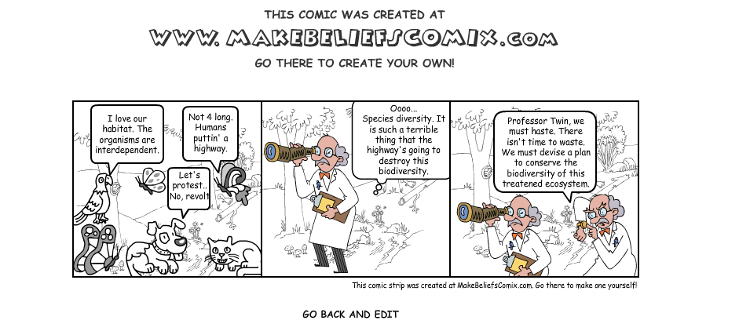
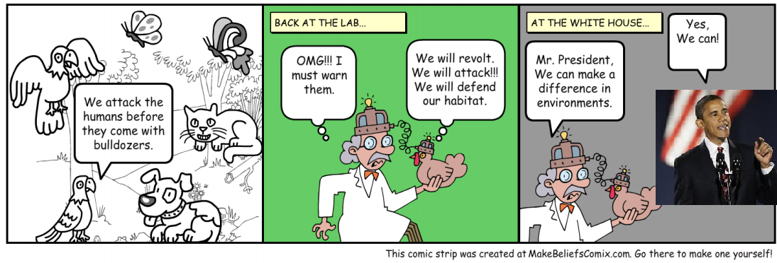
 | Incomplete/Missing (1) | Partially Meets (3) | Meets Expectations (5) | Exceeds Expectations (6) | Student Score
Panels | Comic strip has less than 5 panels that depict biodiversity. | Comic strip has 5 panels that depict biodiversity. | Comic strip has 6 panels that depict biodiversity. | Comic strip has more than 6 panels that depict biodiversity.
Details | Pictures have little to no detail. There are only 2 or less animals/plants depicted in the pictures. | Pictures have some detail. There are 3 to 4 animals/plants depicted in the pictures. | Pictures have detail. There are 5 to 6 animals/plants depicted in the pictures. | Pictures have many details. There are 7 or more animals/plants depicted in pictures and colors are used.
Understanding | Comic strip has panels but they do not depict a subtopic of biodiversity. | Comic strip has 1 or 2 panels that show a diverse environment. Other panels do not clearly depict a subtopic of biodiversity. | Comic strip has 3-4 panels that show a diverse environment and other panels clearly depict a subtopic of biodiversity. Dialogue bubbles and panels helps to covey a clear message. | Comic strip has 5 or more panels that show a diverse environment and other panels clearly depict a subtopic of biodiversity. Dialogue bubbles and panels covey a strong message.
Explanation | There is less than 1 paragraph of explanation provided or no explanation. | There is 1 paragraph that does not clearly explain the chosen biodiversity subtopic and/or does not explain how the message is developed in the comic strip. | There is 1 paragraph that explains the chosen biodiversity subtopic and explains how the message is developed in the comic strip. | There is more than 1 paragraph that explains the chosen biodiversity subtopic and explains how the message is developed in the comic strip.
Grade = Student's Total Points x 5
Name ____________________________________________ Date _______________ Period ___________
Biodiversity Comic Strip Rubric

