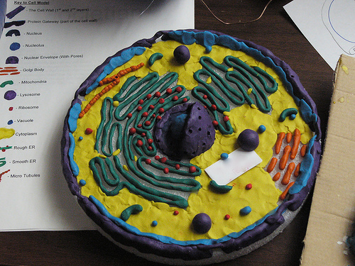
Cell Model Project: Making Three Dimensional Plant and Animal Cells
DUE: TUESDSAY, January 20, 2015

Purpose: The purpose of this activity is to provide students with a hands-on activity that will enhance their understanding of the 3-D characteristics of cells while reinforcing knowledge of plant and animal cell structures.
Procedure:
1. Decide which cell you want to create. You can do either an animal cell or a plant cell. Remember the Animal Cell has to be round and the Plant Cell has to be square. You only have to make ONE cell
2. Use the checklist to make sure you include the correct parts of the cell.
3. Plan! Decide how you are going to make your cell 3-D. Remember: just drawing it or making a poster is not 3-D. Example pictures are included.
4. Below you will find some suggestions and examples.
5. BE CREATIVE! You are responsible for supplying the materials required.
6. You may use any materials to make your 3-D model. Just do your best to be creative!

Cell Structures and Materials:
Make sure to complete the below chart before you make your model, so you know beforehand what objects you will need to represent each part of the cell. You should decide beforehand whether you are making a plant cell or an animal cell. Use the pictures of the cell we have colored to help you with this.
**NOTE: Extra points will be given for each cell part that “makes sense”—that is, materials that match the functions of the cell parts. For example, using a battery to represent the mitochondria, the power house of the cell.
# | Cell Structure | Is it included? If so, check it off in the first column
1. | Cell membrane | Material using:
2. | Cell Wall (Plant) | Material using:
3. | Cytoplasm | Material using:
4. | Nucleus | Material using:
5. | Nuclear Membrane | Material using:
6. | Ribosomes | Material using:
7. | Mitochondria | Material using:
8. | Vacuole (large and central in plant; small and numerous in animal) | Material using:
9. | Lysosome (Animal) | Material using:
10. | Golgi body | Material using:
11. | Endoplasmic Reticulum | Material using:
12. | Chloroplast (Plant) | Material using:
REMEMBER: Each part of your cell needs to be labeled on your 3-D model

Student Examples

More Student Examples

 | 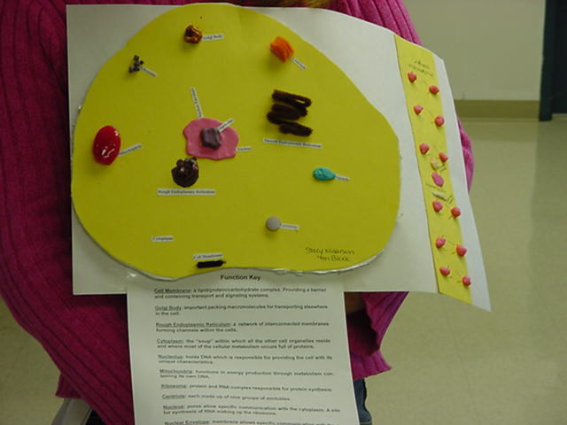 | 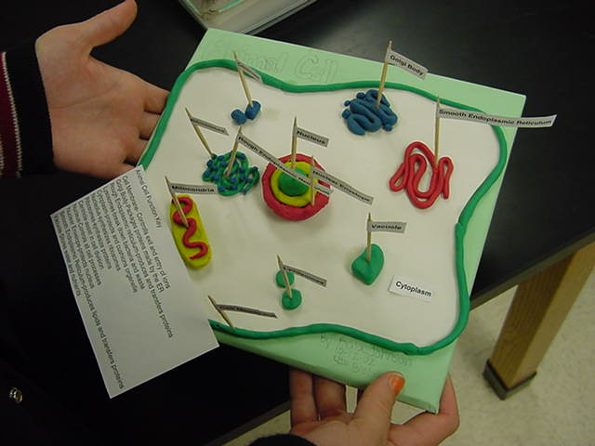 | 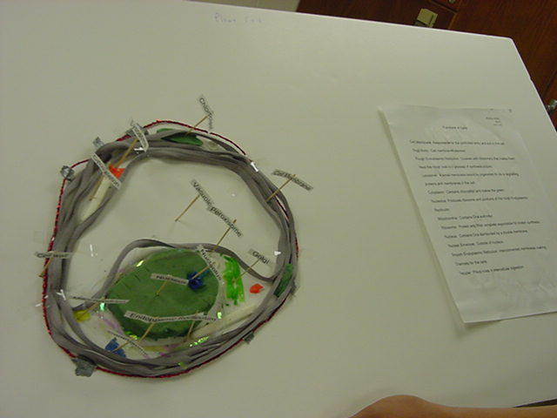
 | 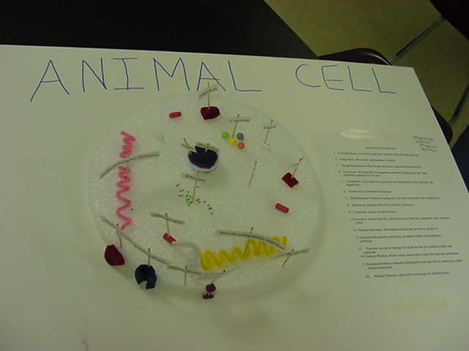 | 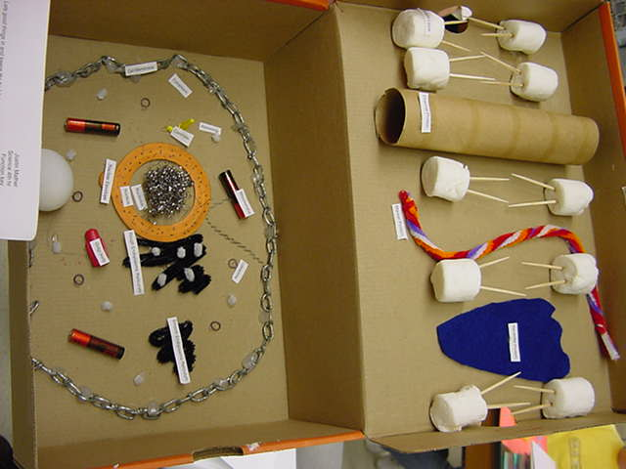 | 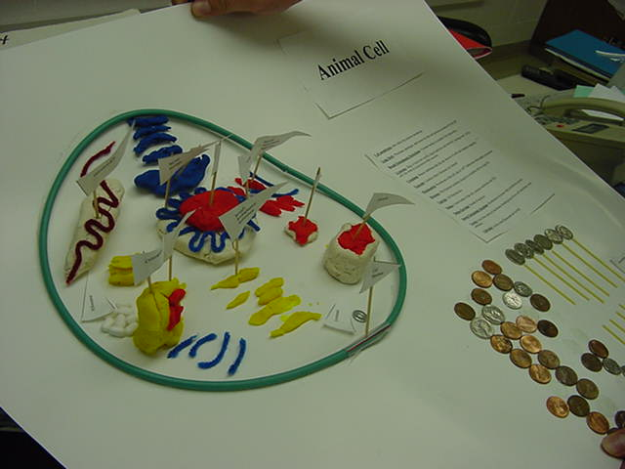
 | 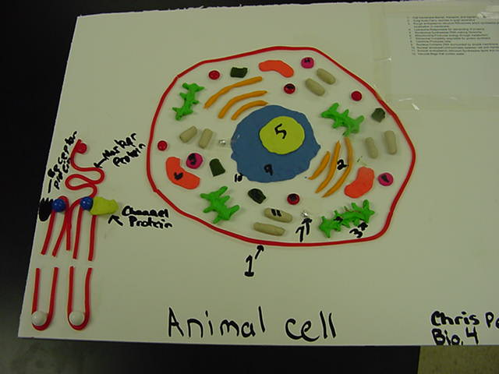 | 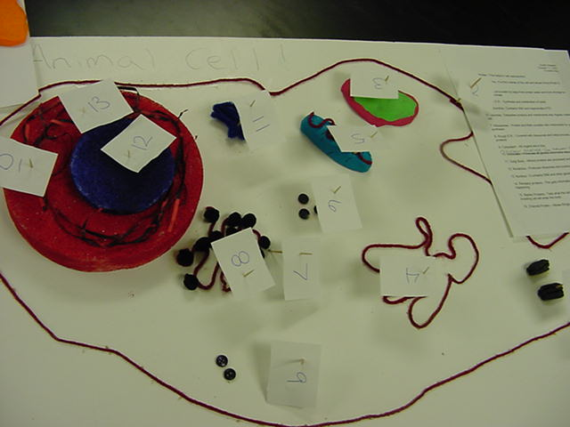 | 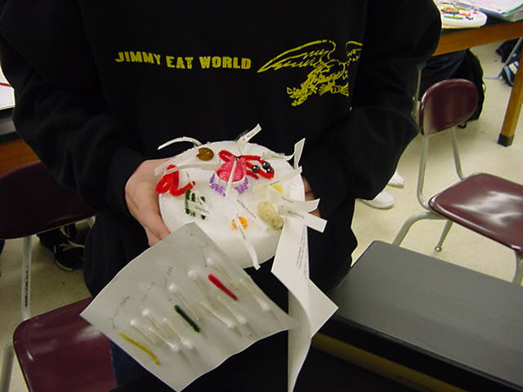
 | 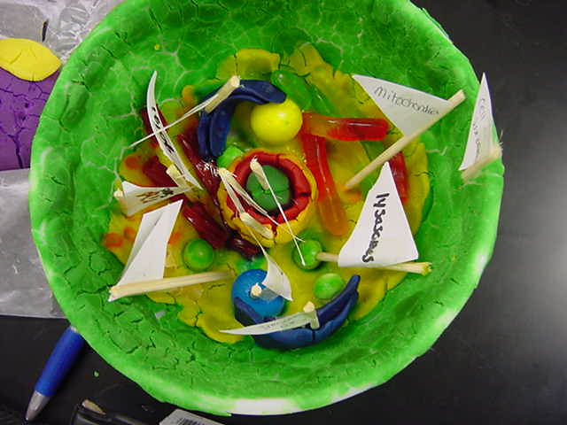  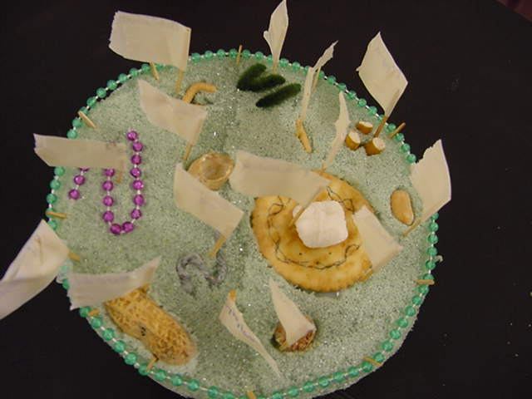 | 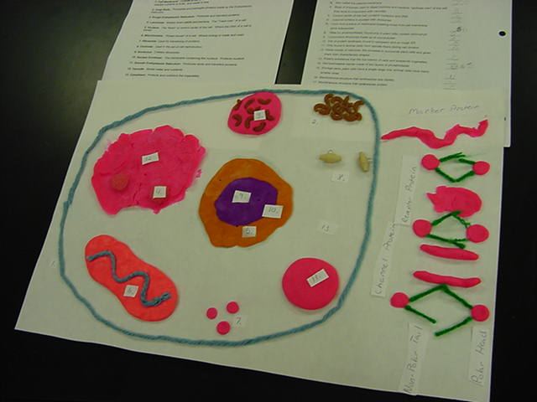  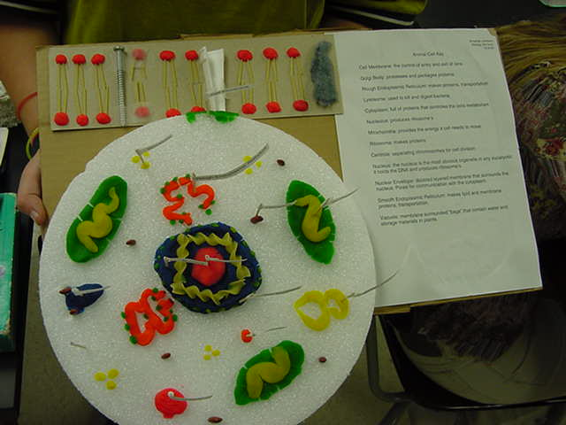 | 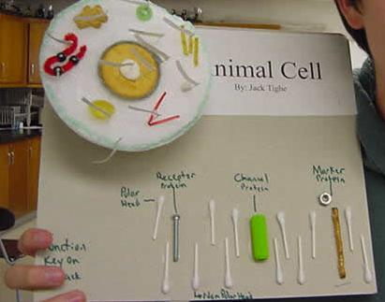  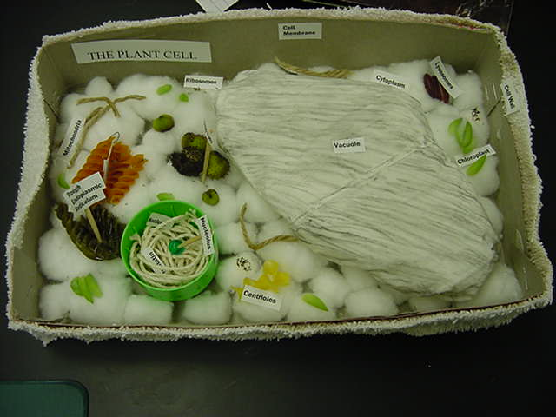
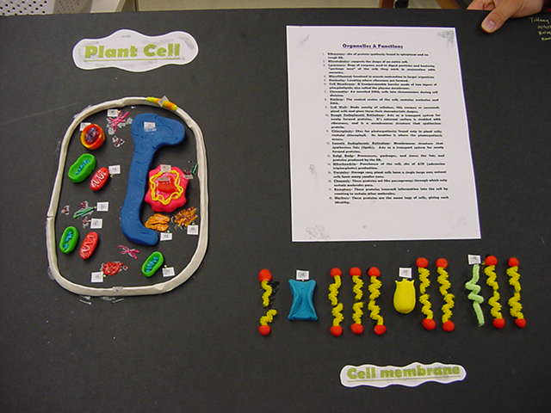
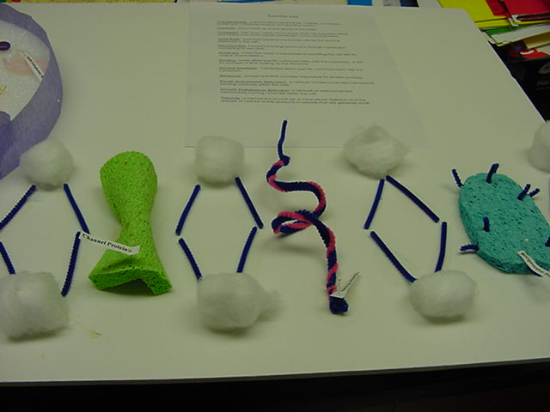
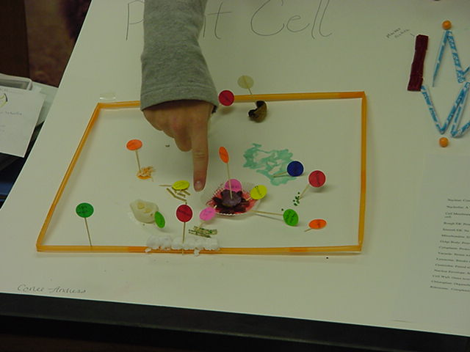

Things I will expect to have for the final project:
- 3-D cell model
- All parts of the cell labeled on your 3-D model
- A one-page paper explaining how you made your project.

Name:_________________________________

3-D Animal and Plant Cell Model Project Criteria For Success

Grading:

On the final project:
- Missing a cell part (deduct 5 points for each cell part)
- Missing a label on a cell part (deduct 5 points for each label)
- Cell part is mislabeled (deduct 5 points for each mistake)
- Plant cell is not square or Animal cell is not round (deduct 10 points)
- Project is sloppy (deduct up to 10 points)
- Project is not three-dimensional (deduct 20 points)
- 1-page paper is missing (deduct 20 points)
- Project is late (deducted: 10 points per day: after 5 days project grade is a 0)

!!!! Remember: Your project grade is worth 250 points total. It is intended to help you better understand the cell and improve your grade. Please take this seriously and turn it in on time !!!!

Cell Part (10 each) | Present | Label | Total
Cell Wall
Cell Membrane
Cytoplasm
Nucleus
Smooth ER
Rough ER
Ribosomes
Golgi Body
Vacuoles
Mitochondria
Lysosomes
Chloroplasts

General Project Guidelines | Total
Plant cell is square or Animal cell is round (10)
Neat (10)
3-Dimensional (10)
1-page Paper (100)
Late: Date turned in: __________ # of days late:_____________

Final Grade: __________/250__
Comments:

