Cell Transport Animations Webquest
Molecules Move Across the Cell Membrane
http://www.sumanasinc.com/webcontent/animations/content/diffusion.html
Summarize the animation in your own words.
____________________________________________________________________________________________________________________________________________________________________________________________________________________________________________________________________________________________________________________________________________________________________________________
Complete the activity.
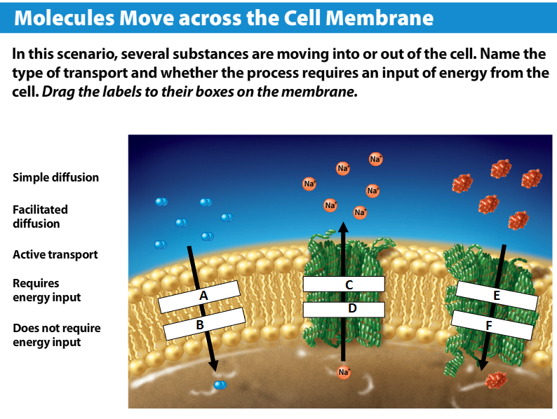
A. ________________________ C. ________________________ E. ________________________
B. ________________________ D. ________________________ F. ________________________

Animation: How Facilitated Diffusion Works
http://highered.mheducation.com/sites/0072495855/student_view0/chapter2/animation__how_facilitated_diffusion_works.html
Watch the animation and complete the statements or answer the following questions.
1. A special ____________ ________________ with a central __________________ acts as a selective corridor which helps _______________________ move across the _______________________.
2. True or False. The special carrier molecules that form the protein channel bind to any molecules floating near it.
3. Write 3 important facts from the animation regarding facilitated diffusion.
a. ___________________________________________________________________________________________
b. ___________________________________________________________________________________________
c. ___________________________________________________________________________________________

Animation: How Osmosis Works
http://highered.mheducation.com/sites/0072495855/student_view0/chapter2/animation__how_osmosis_works.html
CFUs: Answer the following questions after viewing the animation.
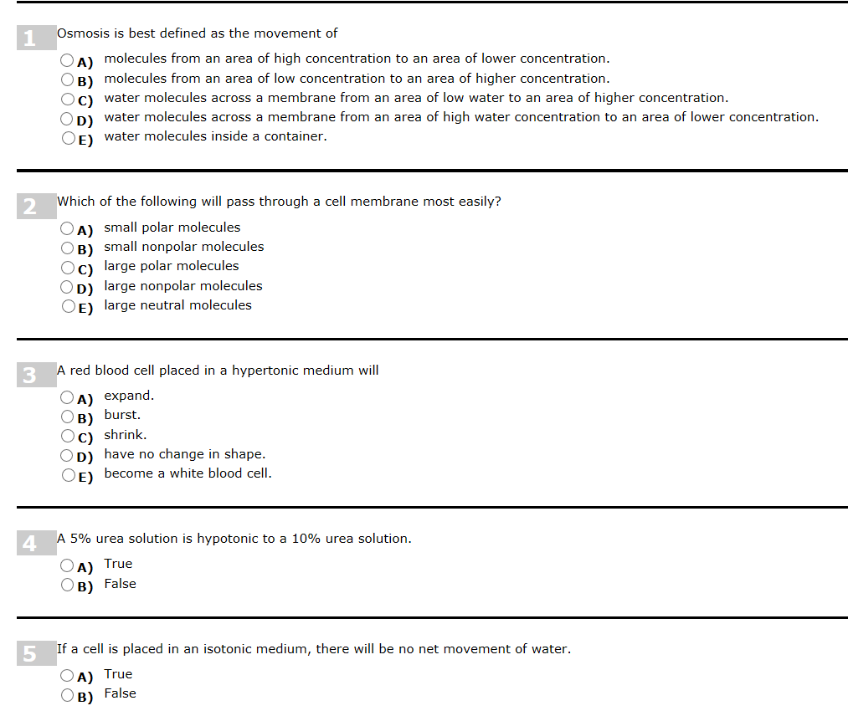This tutorial starts at 1.1 Role of Transport in the Cell and ends at 9.1 Exocytosis - secretion.
http://www.johnwiley.net.au/highered/interactions/media/Foundations/content/Foundations/cell2a/screen0.swf
1. What cellular functions are involved in the transport of chemicals across the plasma membrane?
____________________________________________________________________________________________________________________________________________________________________________________________________________________________________________________________________________________________________________________________________________________________________________________

2. List the passive transports. a. ________________________________ b. ________________________________
c. ______________________________________ d. ___________________________________________________

3. List the active transports. a. _______________________________ b.___________________________________

4. Why is phagocytosis important? ________________________________________________________________

5. How do cells get rid of waste? __________________________________________________________________

