Cells Webquest
Note: Takes about 40 minutes to complete!
WEBSITE #1:
http://www.cellsalive.com/cells/3dcell.htm
1. There are two types of cells. PROKARYOTIC= ______________________
Eukaryotic= Plants and _______________________
2. What types of cells do YOU have (PROKARYOTIC or EUKARYOTIC)? _____________________
3. Which type of cell is more complex (complicated)?_________________________
4. Which type of cell is more simple? _____________________________

WEBSITE #2:
http://www.cellsalive.com/cells/bactcell.htm
This is a picture of _______________________________which is a type of PROKARYOTIC CELL!
DRAW A ROUGH SKETCH OF THE BACTERIA BELOW:

WEBSITE #3:
http://www.cellsalive.com/cells/3dcell.htm
CLICK ON “take me to the animation” NOW, CLICK ON “animal cell”
IDENTIFY THE FOLLOWING CELL PARTS IN THE DIAGRAM BELOW:
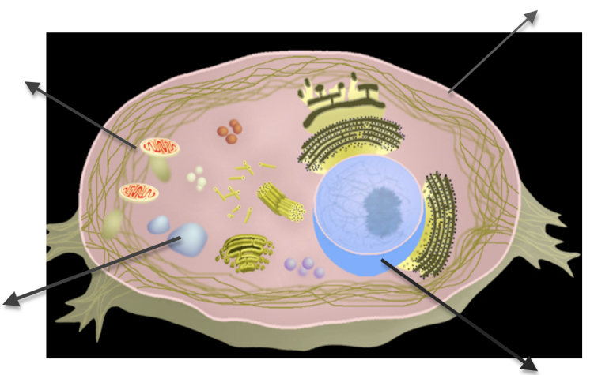
1. Click on CYTOSKELTON. What is the job of the CYTOSKELETON? _________________________
__________________________________________________________________________________
2. Which part of the cell surrounds the cell and allows molecules in and out. This cell part also has holes in it and is said to be SEMI-PERMEABLE.
_______________________________
3. Which cell part contains DNA? _______________
4. Which cell part is the storage center for food and water!___________________

Now go back and CLICK ON THE “PLANT CELL”. Again, IDENTIFY the cell parts in the diagram below.
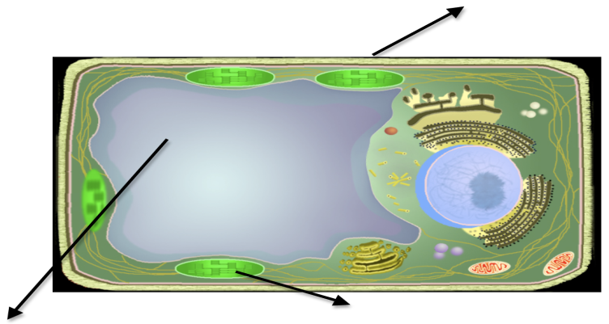
NOT ON THE WEBSITE (See textbook pages 199-200): After observing both plant and animal cells. IDENTIFY
TWO DIFFERENCES between them!
1. _________________________________
___________________________________
2. _________________________________
___________________________________
WEBSITE #4
http://www.cellsalive.com/gallery.htm

Check out the CELL GALLERY! Very cool pictures taken with VERY
POWERFUL MICROSCOPES!
Find the picture that show what your RED BLOOD CELLS look like. Draw
what they look like in the box to the right.

WEBSITE #5:
http://www.scsc.k12.in.us/SMS/Teachers/Martin/replacementlink.htm
What is a Cell?
1. All ____________ things are made up of _________. Each of us has about 50 million cells - an enormous number which is difficult to imagine. Each cell is a sort of bag made from a sort of skin called a __________________. The inside of a cell is ____________ and ____________like. Cells are very ____________ - you can't see them just using your eyes. You need to use a __________________, which makes them look many times bigger than they actually are.
2. If a cell is cut in half, will it survive? _____________
3. TRUE or FALSE: Some organisms are made up of only ONE CELL!
4. All cells have a _______________________ which separates them from the outside world.
5. What is the function of a CELL MEMBRANE! (Name two!)
A. ___________________________________________ B. _________________________________

WEBSITE #6:
http://www.scsc.k12.in.us/SMS/Teachers/Martin/replacelevelsoforganization.htm
1. Within a __________________________organism there is a ____________________________. Division of labor means that the work of keeping the organism alive is _________________________
__________________________. Each part has a ____________ __________ to do. And as each part does its special job, it works in __________________ with all the other parts.

The arrangement of specialized parts within a living thing is sometimes
referred to as ___________________________________. ________________, of course, are the first level of organization.
2. What is an EXAMPLE of a CELL found in your body? __________________
3. A group of CELLS WORKING TOGETHER is called a ____________________.
4. What is an EXMPLE of a TISSUE found in your body? ____________________________
5. What is a group of TISSUES working together called? ____________________________
6. What is an EXAMPLE of an ORGAN found in your body? NAME THREE!
a. ____________________ b. _____________________ c. __________________________
7. What is a group of ORGANS working together called? ________________
8. NOT ON THE WEBSITE…HAVE TO USE YOUR BRAIN! What are TWO
EXAMPLES of ORGAN SYSTEMS? a. ______________________ b. _______________________
9. Finally, what is a group of ORGAN SYSTEMS WORKING together called? __________________

WEBSITE #7: http://www.sumanasinc.com/webcontent/animations/content/eukaryoticcells.html
