Name:  
Class:  
Date:

Topic/Objective:

Essential Question:

Questions:

**Trophic Levels**

* Each ______ in a food ________is known as a _________ level.
* Trophic levels ___________ a feeding ______ in the _________ of _________ and matter in an ecosystem.

**____________**- the _________ of __________ matter comprising a group of organisms in a habitat.

* As you move ___ a food chain, both available _________ & _________ ____________.
* _________ is transferred upwards but is _____________ with each transfer.

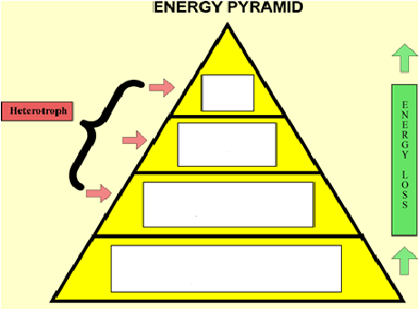

**________ chain**- __________ model that shows how matter and __________ move through an ecosystem

Draw a sample food chain that you might see in Virginia (**in the space below)**: include a producer, a primary consumer, a secondary consumer, and a tertiary consumer

Summary:

Questions:

**Food ______**- shows ____ possible feeding ______________ in a community at each _________ level

* Represents a ____________ of interconnected food _________

**Food chain-** just ___ path of energy

**Food web-** ____ possible energy paths

**Nutrient Cycles**

Cycling maintains _______________ (balance) in the environment.

* ___ cycles to investigate:

1. ________ cycle

2. _________ cycle

3. _____________ cycle

**________ cycle-** evaporation, _______________, condensation, ________________

**_________ cycle-** _________________ and ______________ cycle carbon and __________ _____________-through the environment.

**___________ cycle-**

___________________ nitrogen (N2) makes up nearly ___ %-___ % of air.

Organisms ______ _________ use it in that form.

_____________ and ___________ convert nitrogen into ___________ forms.

Only in certain ____________ and industrial ______________ can _______ nitrogen.

**Nitrogen______________** - __________atmospheric nitrogen (N2) into ________________(NH4+) which can be __________ to make organic compounds like_____________ ___________.

**Nitrogen-fixing_____________:** Some live in a ______________ relationship with plants of the ____________family (e.g., soybeans, clover,____________).

* Some ____________-fixing bacteria live _______ in the_______.

Summary:

Questions:

* Nitrogen-fixing ________________are essential to maintaining the fertility of semi-__________ environments like ______ paddies.

**__________ in food chains-**

While energy ____________ as it moves up the food chain, __________ ___________ in potency.

* This is called _________________ ________________

Ex: ______ & Bald ___________

Summary: