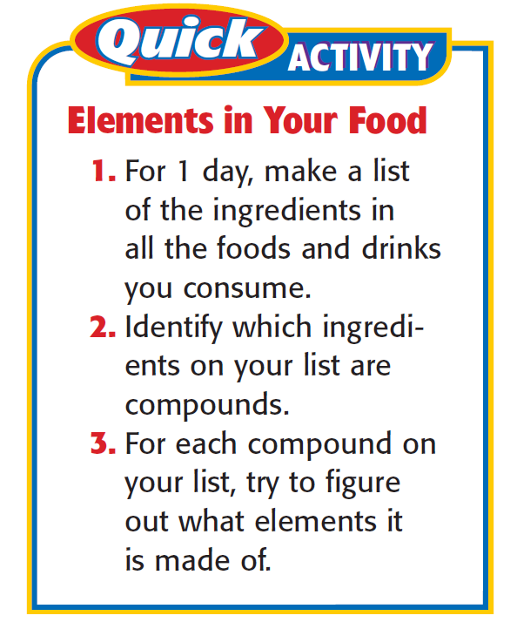

Name ______________________________ Date ____________ Period ________
The Food Investigation – Which elements are in your food?
Record your answers in the data table below.
Food Item | Ingredient | Compound?  (Yes or No) | Elements in Compound

Background research - Pick 3 elements and explain how they are an important part of our diets. _________________________________________________________________________________________________________________________________________________________________________________________________________________________________________________________________________________________________________________________________________________________________________________________________________________________________________

