Name ______________________________________________ Date _______________ Period ______

Frayer Models Homework
Directions: Create a Frayer Model for each of the key terms or concepts in Biology. The goal of the assignment is for students to acquire and understand key vocabulary for success in the course and on the EOC. Use the textbook, your notes, and internet sources with the format below and be sure that you put the definition in your own words. Complete the Frayer Models on your own paper. Put no more than 3 Frayer Models on one side of your notebook paper.

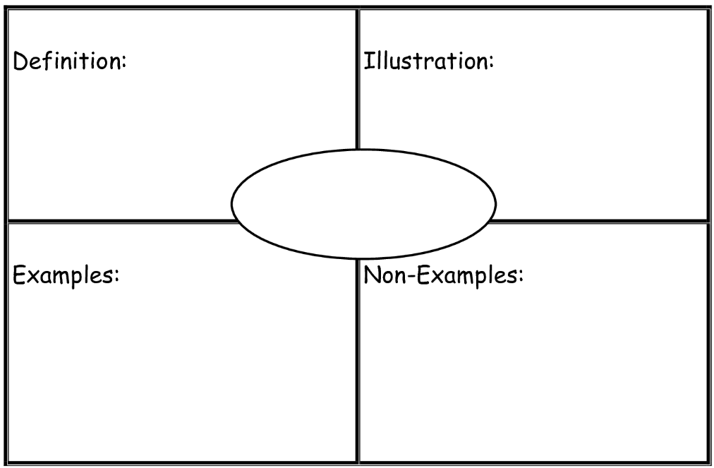

Ecology Vocabulary:

Abiotic Factor  Ammonification/Nitrogen Cycle  Biodiversity  Biome  Biosphere  Biotic Factor  Carbon Cycle  Carrying Capacity  Climax Community  Commensalism  Community  Competition  Consumers  Decomposers  Denitrification  Detrivore | Ecological Pyramid  Ecosystem  Food Chain  Food Web  Host  Limiting Factor  Mutualism  Natural Disaster  Nitrification  Nitrogen Fixation  Organism  Parasite  Parasitism  Pioneer Species  Population | Predator  Prey  Primary Consumer  Primary Succession  Producer  Scavenger  Secondary Consumer  Secondary Succession  Symbiosis  Tertiary Consumer  Trophic Level

