Tonicity of Solution | Concentration of  Solute (outside of cell) | Water (outside of cell) | Net Movement | End Product
Isotonic | Same as cell | Same as cell | None | None
Hypotonic | Less than cell | More than cell | Cell gains water | Swells, turgor pressure
Hypertonic | More than cell | Less than cell | Cell loses water | Shrinks plasmolysis
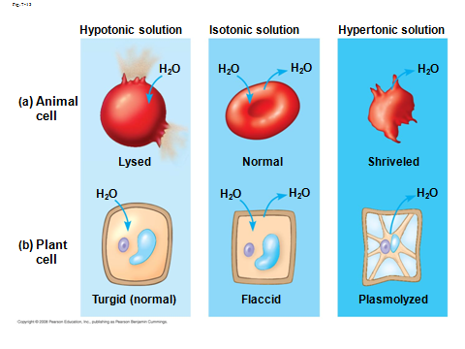
Know the vocabulary:
Osmosis
Osmotic Pressure
Hypertonic solution
Hypotonic solution
Isotonic solution
Turgid
Flaccid
Plasmolyzed
Hemolysis
Crenate / Crenation

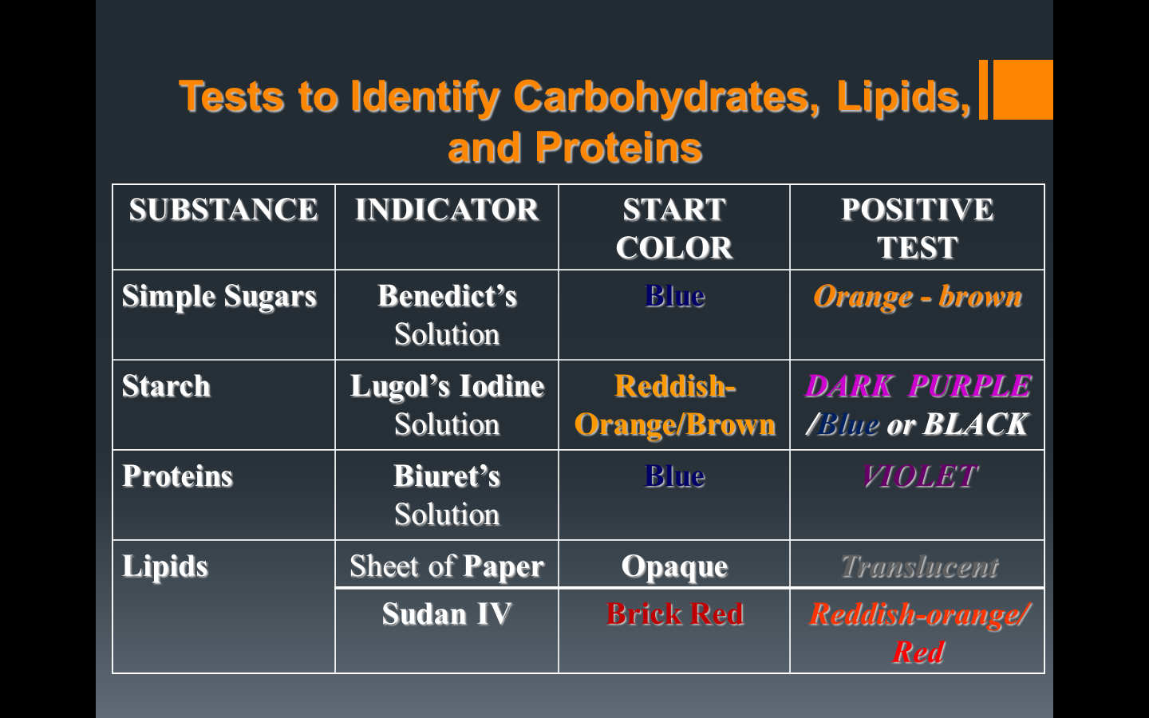
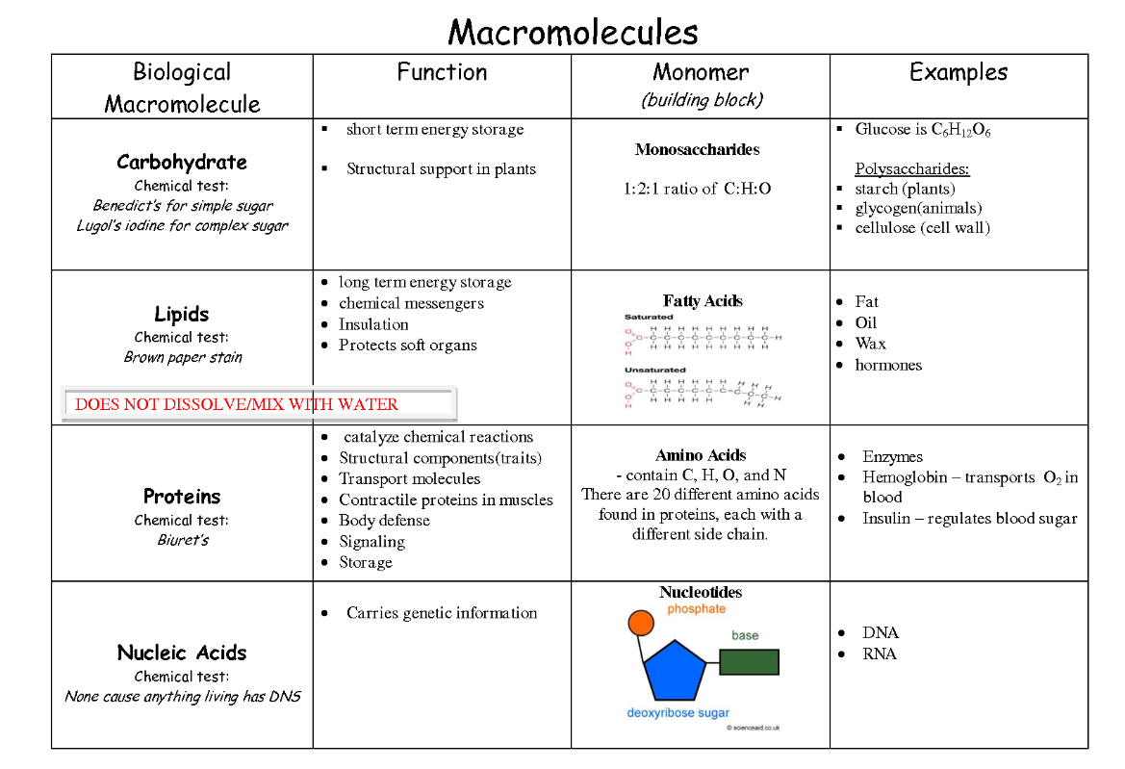
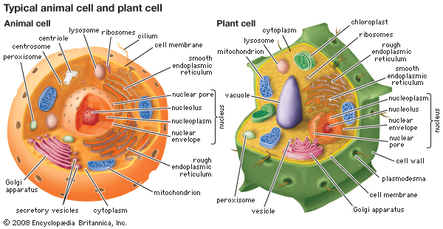
See page 199 in the textbook for the functions of the cell organelles
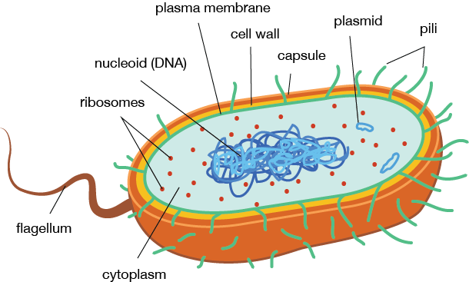
Bacterial cell
